HIGH-LEVEL FRAMEWORK FOR DISCUSSION WITH TEMI

- Governance Structure.
- Entity formation
- Set up an Incorporated Trustee for Management of the Hub (focused on strategic management and overall oversight on the operations of the Hub)
- Set up a Limited Liability Company for investment Purposes (Serve as in investment vehicle for the State and other interested participant

- Governance for Incorporated Trustees
- Must have a Board of Trustee - assume this is the Governing Board and should include the following:
- Government Rep
- ICT Infrastructure Provider/Expert
- Serial Entrepreneur/successful Tech Start-Up Founder
- Legal and Regulatory Policy Expert
- Accademia
- Large Corporate (Tech/Telecoms/Finance/FMCG)
- Media (Digital) Specialist
- Executive Secretary

Note – Board of Trustee should be chaired by an independent and Board positions will be non-remunerated except for the executive Secretary.

- We need an operating rule for the Governing Board (Charter) covering:
- Composition
- Tenure
- Funding and administration
- Meetings
- Operating framework for Management
- Program management oversight
- Investment and Joint Venture oversight

- Set up Board and Management for the LLC
- Will manage Government’s mandate to participate in investment vehicle
- Will be independent of the Hub and the Governing Board but should have Board Member sit on the Governing Board of the Hub.

- Operating Framework

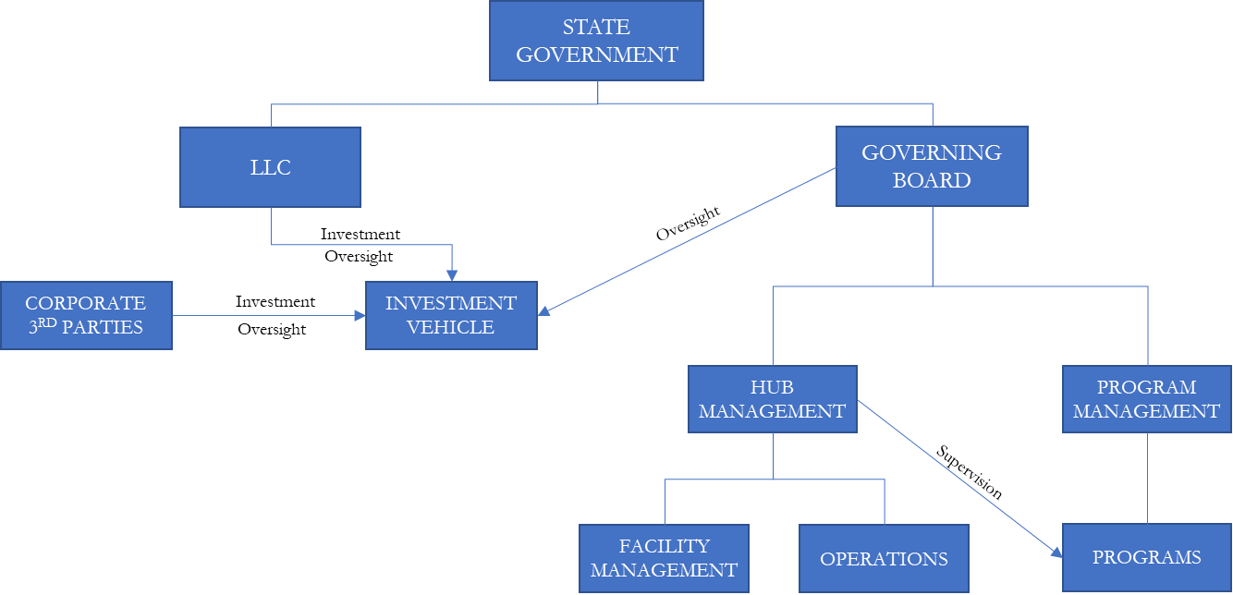
- Funding Structure
SOURCES
Facility Partnership
Dedicated Programs
Sponsorship
Events
Government
Investment
ACTIVITIES
Branding, Infrastructure support, etc.
Certification programs, AWS, Microsoft, 3rd party content programs, etc.
Hub led corporate support for programs
3rd Party Rentals
Funding support
Return from LLC

